
Central Ealing Neighbourhood Plan
Consultation Statement to accompany the Plan submission

- Introduction: Origins
Ealing has a long history of community engagement in the development of the town centre. Civic involvement over the past decades includes strong local opposition to major redevelopment plans for the town centre in the 1960s, which successfully led to alternative proposals for what is now the Ealing Broadway Centre. Further significant campaigns in the last few years have concerned plans for Dickens Yard, the West London tram, development of the Arcadia site and the rebuilding of Ealing Broadway station for Crossrail.
Proposals were submitted in mid-2007 by developer Glenkerrin to the London Borough of Ealing as the Local Planning Authority (LBE), for the rebuilding of a large part of central Ealing (the Arcadia site). This led to the formation in October 2007 of the Save Ealing's Centre alliance (SEC), an umbrella group of 27 residents’ associations and local community organisations opposed to the development. The rejection of the Arcadia plans after a public Inquiry in 2009 led to increased interest in finding a better way for planning the future of the town. Provisions in the Localism Bill to allow communities to plan their own neighbourhoods stimulated parallel approaches to LBE in May 2011 by SEC and the Ealing Broadway Business Improvement District Company (BID), suggesting that Ealing should become a “front runner” under the government’s localism programme.
In response, LBE invited Civic Voice to help explore the potential for neighbourhood development plans (NDPs) in Ealing. Two workshops took place in September and October 2011, attended by an invited group from the BID, SEC and several local school pupils (see report in Appendix A). It was followed by an application by LBE to the Department for Communities and Local Government (DCLG) for front runner status, which was granted in March 2012. In the same month, an LBE presentation was made about possible implications of localism and neighbourhood planning to a meeting of the Ealing Council for Voluntary Service (ECVS).

- Deciding the Neighbourhood Area (NA)
The application to DCLG was drafted by LBE and included an outline of the proposed NAs based on the boundary of the Ealing Metropolitan Town Centre (EMTC), divided between the Ealing Broadway area and West Ealing centre. This division followed the recommendation of both SEC and the BID, as recognising the existence of two separate community and retail areas separated by a stretch of mainly office buildings. Following acceptance of the application and recognition of both areas as qualifying as front runners, an interim neighbourhood forum was set up in May 2012.
The new body took soundings from its constituent stakeholders and recommended some changes to the original area, adding domestic properties bordered the EMTC, extending its boundaries to include the main campus of the University of West London (UWL) and removing the illogical omission of half of Walpole Park. A map and statement (Appendix B) which identified the area to which the proposed NDP related and which accompanies this consultation document was submitted to LBE on 28 August 2012, for designation as an NA.
On 7 September 2012 the LBE began a public consultation on the proposed boundary. This ran for six weeks to 19 October 2012. No formal written representations were received, and on 29 October 2012 LBE confirmed that the proposed boundary was acceptable without the need for any changes. Both Central Ealing and West Ealing Centre were designated as “business areas” for the creation of NDPs.
- Engagement strategy
The working group which had been convened in May 2012 was drawn from a wide cross-section of the local community, with over 50 stakeholders (representatives and individuals) invited to participate (Appendix C). An interim committee including representatives from LBE agreed that the proposed aims for a neighbourhood forum should include establishing the means to engage the wider community and a draft constitution was prepared which balanced the full range of local interests. Steps were taken to launch a web site with the help of the Ealing, Hammersmith and West London FE College, and to establish links with inward investors and developers.
The nature of the NA, as primarily a commercial one, has determined the way in which our aim to engage all those with an interest Central Ealing has been fashioned. As defined above, the core area contains a relatively small number of residential properties, which in 2012 was calculated to be home to a fairly transient population of around 1,500 people. The rest consists of retail and commercial businesses, together with UWL, the Ealing campus of the College and some significant cultural institutions alongside the borough’s main offices and town hall.
However within a radius of 1.5km or half a mile immediately outside the boundary of the NA, there is a much larger residential area housing over 14,000 people, who look to Ealing Broadway as their natural local shopping and leisure centre. The Area section of the NP (Section 2, para 2.10) notes that development in the centre has a significant impact on these local residents, even though they are not within the NA. Recognising their proper interests is a challenging aim given the many roles Ealing town centre fulfils, and has been a continuing concern of the Forum.
The Central Ealing Neighbourhood Forum (CENF) was formally constituted at a full open meeting of stakeholders on 4 December 2012 and provides for equal representation from businesses, residents and voluntary organisations. From the start it was recognised that the Forum had a duty to be open and transparent about its work. Minutes of meetings are posted on the website, and a full email list was compiled so that regular bulletins on news and progress could be distributed. The constitution also provides for a quarterly public meeting, open to everyone.

- Stages of consultation
This section of the statement summarises the engagement conducted by CENF over the last four years in developing the NP.
The initial workshops and informal soundings showed clearly that for all parts of the community their wish was for Ealing to be seen once again as the Queen of the Suburbs. It would retain and protect its heritage of green spaces, trees and human scale, and re-establish itself as the West London regional centre for arts and culture with a strong independent retail and business base. This became the core Vision for the first drafts of the policies and recommendations in the NP, and has guided the work in creating policies to achieve these aspirations and objectives.
Converting these broad objectives into a set of specific policies meant we had to identify particular areas where a local plan could be effective. Our strategy has been to take a staged approach, allowing for regular consultation. This can be broken down into three broad phases:

  - Phase 1 evidence collection/emerging ideas (2012/13)
  - Phase 2 drafting and testing the plan (2014)
  - Phase 3 finalising the plan (2015/16).
Each one of these is addressed below.

- Phase 1 – evidence collecting and emerging ideas 2013
On 11 January 2013 the council started a six-week statutory public consultation on the proposal to designate a neighbourhood forum for Central Ealing. This closed on 22 February 2013. Five formal written representation were received, and on 27 March 2013 LBE formally designated CENF as the body capable of bringing forward proposals for neighbourhood planning in the area, subject to meeting some conditions which were met in April.

Early discussions in 2012/13 during the period leading up to the formal recognition of CENF had identified a range of issues which concerned people. The initial working group undertook a series of presentations and discussions with stakeholders, which led to four topic groups being set up. In April 2013 it also considered a range of activities, possibly involving outside consultant help, to improve engagement with as wide a range of the target audiences as possible (Appendix D).

Through 2013, a series of meetings was held with community groups, local residents, business organisations and politicians. These were underpinned by quarterly meetings of the full open Forum and by attendance at other organisations’ events. At these meetings ideas were discussed and evidence collected to start to develop concepts for the plan.

The meetings included:
- Jan/Feb: BIDCo discussions with groups of their levy payers
- Feb: First full Forum public meeting
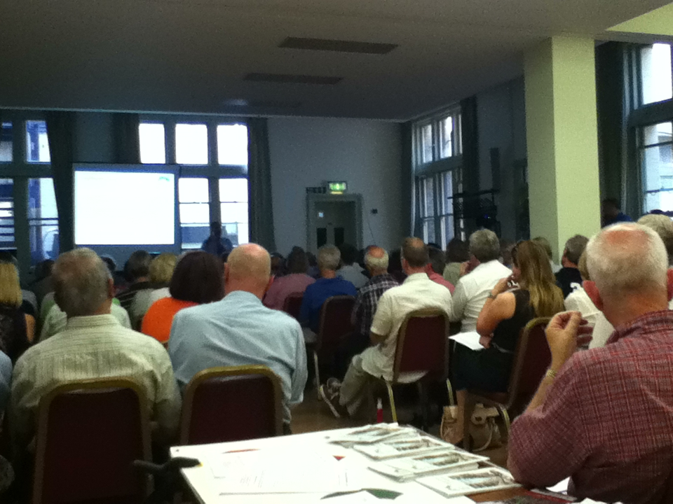
- March: Contacts with two developers (Land Securities and Benson Eliot) about their plans
- April: Forum received feedback from the four topic groups
- June: Special open workshop facilitated by external consultants (Imagine Places) to discuss the context, coordinate a vision, set priorities and agree work streams.
- July: First Forum AGM, attended by 140 people (right)
- Nov: Full Forum public meeting to report on first phase consultation results.

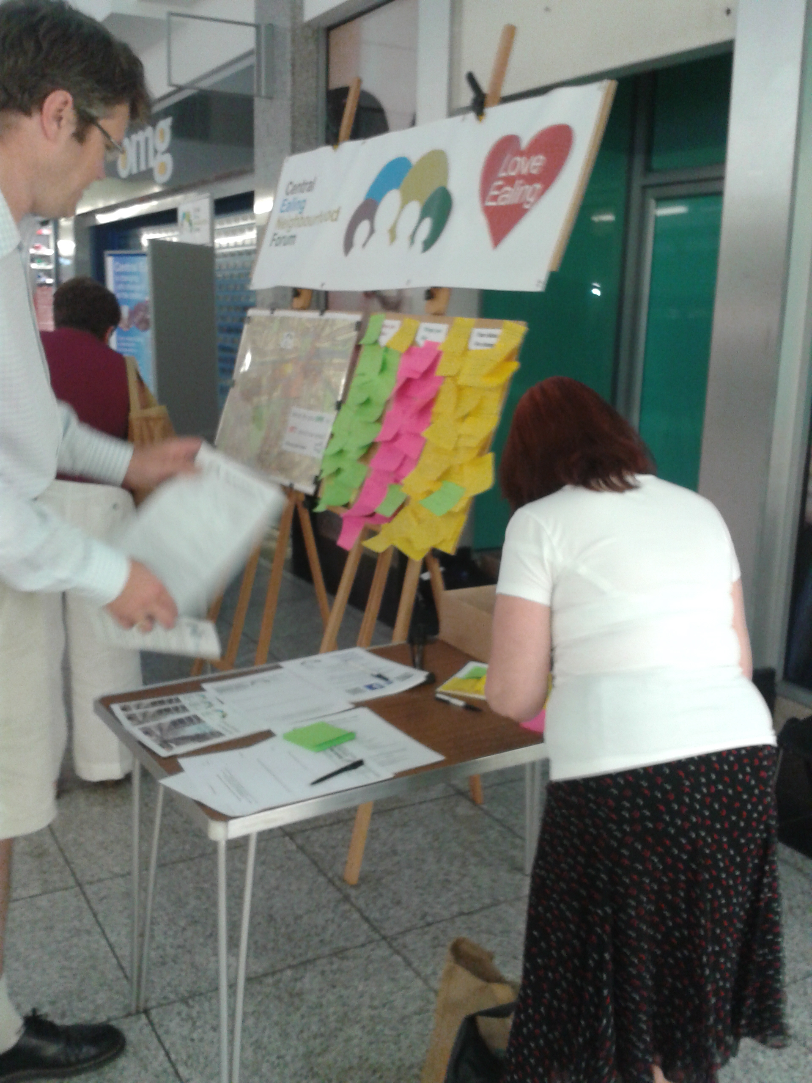
To support this first phase of engagement, an introductory booklet (Appendix E) was dropped to 7,500 homes housing some 13,000 voters. This set out the challenge for the area and asked for ideas. The booklet was also promoted through the 27 organisations making up Save Ealing Centre and through a display in a series of street stalls which invited contributions to a survey of “likes, dislikes and needs” (left). Over 300 comments and suggestions were made, and by September 275 people had signed up to the email subscription list as actively interested parties, of around 1,000 people assessed as engaged.

A new website, www.centralealingforum.com was established at the same time, with a Facebook page CentralEalingForum and a twitter page @EalingForum.
Phase 2 – drafting and testing the emerging plan 2014
The second phase was to develop this work though contact with a wider range of interested parties. By early 2014 CENF had around 300 people on its database making it easier to promote research. Working groups were set up to review the contributions received under five headings:
- The Vision
- Shops, offices and jobs
- Getting around
- Open space and heritage
- And perhaps most regularly, Ealing’s culture.

The topic groups had the task of analysing the data and the need for evidence to back any policies developed out of the responses received, which were posted on the website and reported to the full Forum meeting in March. The first step was to agree a vision statement, which was also promoted on the website and reported to the AGM in June.

“Our vision for change is for Ealing to become once again a sought after destination and a natural focus for both the Borough and the West London sub-region. Development must enable it to meet the challenges of its rapidly increasing residential population and improved accessibility, whilst preserving its special and historic character. Our vision is that by 2026 Central Ealing will have restored its position as a distinctive and welcoming place attracting people from a wide catchment area to visit, work, study, shop and stay. It will:
- be a regional centre of excellence for culture and education
- have preserved its historic character and heritage of green space, trees and human scale
- regain its competitive edge with a renewed shopping experience and a vibrant mix of retail and complementary uses and facilities
- have a network of attractive streets and public spaces which encourage pedestrian use and cycling and which move the balance away from the dominance of cars
- deliver a safe and welcoming evening economy
- be a desirable location for visitors to London to stay with new hotel and visitor attractions
- provide new leisure and recreational facilities
- be an integrated and balanced community, catering for diverse and changing needs across all age and social groups
- and support a sustainable local economy and be a good place to start and build a business.”
Based on this vision and broad objectives, four sets of broad policies emerged from the working groups for further development. It was decided to carry out two elements of consultation – first an online survey (Survey Monkey) and second some research with young people in the borough.
A second brochure/booklet “Your Town, Your Plan” (Appendix F.1) and a publicity flier (Appendix F.2), was produced in time for the AGM and distributed in both hard copy and electronic form. This set out the topics in more detail and the group leaders for each. For each topic an “issues and options” paper was developed and reviewed with outside consultant help from Planning Aid to ensure that the issues were properly covered and the options broadly met the Neighbourhood planning criteria.
The Survey Monkey questionnaire reproduced the brochure approach, including the opportunity to make both detailed and general comments in each topic section, together with personal data to enable assessment o be made of the representative nature of the replies.

The survey
  - was promoted via 300 email contacts, 350 social media, 2000 homes via the SEC database, an A5 leaflet drop to 750 homes in area, festivals, street stalls and via the BID. 250 printed questionnaires were sent out to libraries and the Town Hall
  - had 33 questions to reflect the specific draft policy ideas.

A 79 page report summarising 283 replies was generated by Survey Monkey (Appendix G). In addition, a further 200 people signed up to the email list, taking the total to over 500.

The youth contact exercise took place 12 October 2014. A brief was developed aimed at reaching young people. It was tendered to three agencies, and Imagine Places and Sticky World were appointed to develop the theme and the process, which was based on a one day workshop and exhibition.

Initial response was poor, so the exercise was quickly redesigned to engage people on the day and exhibit their ideas. It elicited 61 responses from people aged between 16 and 30, plus 40 ideas from people aged over 30. There were 915 online ‘room views’ for the ideas, with 362 votes being cast and all but two of the 61 ideas got votes.

Most popular idea was return of a cinema, followed by an arts centre. Younger people’s focus was less on planning issues and heritage, more on better public realm, cleaner and livelier places. An exhibition of the contributions was held in the evening to show the range of ideas elicited.

This research was supplemented by meetings as set out below:
20 March - Forum meeting
28 May - meeting of NFs from across London.
25 June - Forum AGM
8 October - Forum meeting
Meetings were also held with LBE planners on 14 January, 14 August and 20 November to discuss progress.
- Phase 3 Finalising the plan 2015/16

The early part of 2015 was devoted to assessing the results of the Issues and Options consultation, in particular the detailed analysis provided from Survey Monkey and external advice from Planning Aid concerning the adequacy of the evidence base and conformity with existing strategic policy. In June progress was reported to a full Forum meeting and to a meeting of the Ealing Business Partnership.
At the same time an external consultant was engaged to help with writing the full plan.

Comments were also received from LBE planners in August, which were considered along with the other input and resulted in several changes to the original draft policies. Discussions were held with the owners and/or main leaseholders of the principal sites where the draft policies would have specific impact. (These were originally designated as “site specific policies”, but on advice from LBE have since been relabelled as “Site specific policy applications”, to clarify the fact that these are not identified as particular development sites.)

It had originally been intended to complete drafting of the full plan and to carry out the Regulation 14 consultation during the late summer/early autumn period. However this timetable clashed with other LBE public consultations and with the campaign and vote by business levy payers on the BID’s renewal of its mandate. To avoid slipping into the pre-Christmas period, the formal consultation was deferred until the New Year. This also allowed more time to consider comment on the revised policies, which were published in draft on the web site in November, and to submit the total plan for an external professional ‘health check’, which was completed in January.

LBE had reserved its position on the revised draft and suggested that we should proceed with the consultation and they would comment later. Accordingly the formal start of consultation took place on 22 February with statement to the media and on the Forum’s web site. A meeting with LBE subsequently took place on 16 April, when a number of detailed points were raised.

The plan document was published on the web site under the repeat title “Your Town Your Plan” (Appendix H) along with a detailed Survey Monkey response questionnaire. Notice was sent to the full email list (by then 515 subscribers), to the BIDCo for the information of its 500+ levy payers, to the Ealing Council of Voluntary Services for notification to its 500+ members, and to SEC for its 27 member organisation. (LBE also undertook to notify its list of organisations and individuals registered as interested in local planning matters, though it appears this never happened.) Printed copies were made available in the central public library and in the public reception of the Council’s service centre. The plan was discussed at a full Forum meeting on 22 March, and meetings of the three local Council ward Forums were addressed during the period. 5,000 A5 leaflets (Appendix I) were printed and distributed at these and other meetings and public locations.

Individual letters were sent to a full list of statutory consultees, either by email or post as indicated on contact details as previously provided by LBE (list attached as Appendix J). Recipients were invited to respond directly by letter or email, or through the online survey form.

Initial response was slow, due it is thought to the Easter holiday break, so it was decided to extend the closing date to 18 April. This was also publicised to the email list, and through the Facebook and Twitter accounts.

Details of submissions received, and the response to these in finalising the plan for formal submission, are covered in the next section.
Summary of issues raised and addressed.

The initial phase of identifying issues from the likes, dislikes and wants consultation produced some clear areas of public concern, as listed in section 6. Options to address these issues were tested in the Issues and Options consultation in phase 2, and converted into draft polices in the third phase.
The Regulation 14 consultation produced 242 comments on the proposed policies from the 52 submissions listed in Appendix K, together with further input on the Recommended Actions. Full details of these comments and the responses to them are in a full report (Appendix L). The most substantial of these are summarised below.
Policy no/Issue | How addressed
E1 Need for shop front guides | Added as a Recommended Action
E2 Better definition needed of over-concentration of uses | Wording revised using examples from other plans
E3 Objection to fixed % for scale of development requiring space for social, cultural and community use | Specific size provision removed
HBE1 Objection to exclusion of minor works | Exclusion removed
HBE2 Confusion of ‘views’ and ‘settings’ | Wording amended to be more specific on which views and vistas should be protected.
HBE2 Objection to specific height restrictions on frontages affecting CAs | Policy reworded to be consistent with existing guidance used in LBE’s site briefs
HBE3 Objections to tall buildings definition & policy | Policy reworded to relate more to context
HBE4ii Objection to restriction on adjacent structures | Justification clarified and strengthened
T3 Policy too prescriptive | Wording modified to allow some flexibility
T4 Safeguards for pedestrians needed | New sentence added
CC1 Objection to requirement to provide space for social infrastructure | Wording modified to be less prescriptive
CC2 Policy should be about facilities. | Policy re-titled

Comments on Recommended Actions have not been listed here, but are covered in the full report.)
Conclusion
The emphasis of the community consultation programme has been to ensure that people are aware of the NP; that they understand its nature and how it might impact on Central Ealing, and that they feel that they have had a chance to contribute and have their comments properly considered.
CENF has sought to engage with as wide a range of organisations, stakeholders and individuals as possible. In developing a Plan for a business area which is part of a Metropolitan Town Centre as well as the heart of the borough which bears its name, it has sought to balance the interests of those who are its immediate residents and businesses with the views and needs of the substantial residential population in the immediate hinterland.
CENF is aware that, despite discussing the emerging Plan with many different groups and individuals, it has not always been able to engage fully with all potentially interested parties, particularly minorities who are not well organised in representative groups. Nevertheless we believe that as a project to involve the relevant electorates it has far surpassed any previous exercise in the borough.
All the views and comments expressed in response to information given and discussions about the Plan have been recorded. It is clear that, from the consultation process, there is strong support for a sustainable Plan that provides for the infrastructure on which to build a cohesive and balanced community in and around the town centre, and where development, whilst recognising the need to respond to the pressures for housing with increased densities, respects its special historical character and the need for a strong cultural base.

Appendices (as electronic files)

      - Workshop report October 2011
      - Application to recognise Neighbourhood Area
      - List of original stakeholders
      - Engagement consultants’ brief
      - First booklet & leaflet
      - Second booklet (Your Town – Your Plan) & accompanying flier
      - Analysis of Issues & Options phase (Survey Monkey survey)
      - Neighbourhood Plan Consultation version
      - Second leaflet
      - Statutory (Reg 14) consultees
      - Reg 14 consultation respondents
      - Reg 14 consultation comments and responses

August 2016

